Global Recession of 2020 its impacts on Economies of United States and China
Your Name
University Name
Instructor Name
Date

Global economies were built around the world on slogan of globalization, open system free market system where imports and exports were made easy for Businesses in order to earn foreign reserves in each of world’s economy but all of sudden everything has stopped, all global economies are forced to go in lockdown and work in close system in order avoid effect prevailing pandemic “Covid-19”.
Finally Global Recession of 2020 has arrived it has come with worst effects of economic indicators globally unemployment will rise, investments will decreases, poverty will increases and problems of recessions will be in multiplier effect.
Global Recession of 2020 is mainly caused by the lockdown of China as most of the largest Multi-National companies operate from china they have productions centers their firms like Apple, Dell etc. as due to lock down they already faced millions of losses whole supply chain is stopped due this Global Recession of 2020.
Historically we do not have such recent examples of Global Recession of 2020 like this in history of mankind last pandemic like this happened way back in year 1918 when Spanish flu affected more than 500 million people.
MNC’s not only just look to manufacture goods in China they have strong base in terms of sales in china, if you look at the sales of KFC it sells more chicken in china now than in United States, General motors having partnership with other Chinese firms they are selling more than 3 million units of vehicles in china annually and many other firms have captured Chinese markets.
Global economies are in recession demand and supplies of imported and exported goods is all most zero except medical supplies is going in some countries otherwise this Global Recession of 2020 has shut down whole world. Global economies are badly affected by this new virus because whole businesses are shut down in most of countries with around 2.6 billion people around the world in some kind of lockdown (Anon n.d.).
Persistent Lockdown has made many people unemployed many businesses are not going to continue their businesses even if this lockdown is over because they are badly affected by this sudden disaster recession is everywhere even those developed economies like Germany, Italy, Spain struggling to meet needs of medical equipment and protective masks.
Poverty will also increase it is believed that Poverty levels in developing countries could be set back by up to 30 years, research released by the United Nations University’s World Institute for Development Economics Research warned on Thursday dt:04/09/2020 (Ahmed 2020).
International Monetary Fund (IMF) has predicted a Global Recession for year 2020which would have long lasting effects than the one triggered by the global financial crisis of 2008 to 2009 but still global economies can recover within one year (hermes 2020).
Impact of Global Recession of 2020 on Economy of United States of America
Lockdown has also reached the one the most powerful economies of world United States of America as pandemic has started showing its economic impacts on US economy which you would not find in the history of America’s economy .Global Recession of 2020 has made millions of lives miserable it is highly likely many people will develop some sort of psychological disorders because everyone is worried, everyone is asking questions like how long it will last?
How deep it will be? Who will be impacted the most? And how swift will the recovery be? Top economist of this era are not confident enough to answer these questions because of complexity of the issue it is not issue of supply shock, financial crisis, a currency crisis, a debt crisis or a balance of payment crisis so such questions are difficult to answer with highly uncertain future due to this Global Recession of 2020.
US economy is one the powerful economies but Global Recession of 2020 will test its every sector of economy and each individual in country will be affected by this pandemic Covid-19 which has caused Global Recession of 2020, the head of the St. Louis Fed expects a 30% unemployment rate and a 50% drop in US GDP by summer. More importantly, as the health crisis rises and crests at different times in different parts of the world, the horrifying numbers on GDP growth, unemployment, business closures are not likely to let up in the near term(Dutt n.d.).
US economic indicators are going down expected GDP is down by 50% as per experts pandemic has shocking resulted in shocking responses people like of big disaster has come everyone is worried about job, finances and healthcare insurances etc. It has been reported that about 3.28 million Americans applied for unemployment benefits, the highest number ever recorded.
Unemployment is shooting up far faster than it did during the 2008 recession, a sign the economy is heading towards recession(Anon n.d.).
US economic figures show consumption plays pivotal part usually 70% Gross domestic product (GDP)constitute of consumption which will be slumped as businesses shutdown from last couple few weeks so consumption trends will significantly differ than usual trends as for now people are fearful of future finances and their jobs.
Investments had usual contributions around 20% of GDP whole businesses down with uncertainty around the future of COVID-19 and its costs. Businesses of restaurants, entertainment, constitutes around 4.2% of GDP with movies theaters and restaurants closed it will also impact US economy another economy contributor of US is manufacturing business but due to stoppage of international business supply chain of those business is affected which normally had contributed around 11% in US GDP(Anon n.d.).
The global financial crisis, the dot-com crash, Black Monday, oil price shocks, 9/11, none of these historic shocks are even visible in the graph (Dutt n.d.).
Following graph shows it is expected the number of unemployed people will increase to 3,28,3000 which is far higher than any past recessions or shocks of US Economy. Situation of lockdown is worsening with each passing day because economies forced to shut down stock markets are on lowest index numbers nothing is working in situation like this.
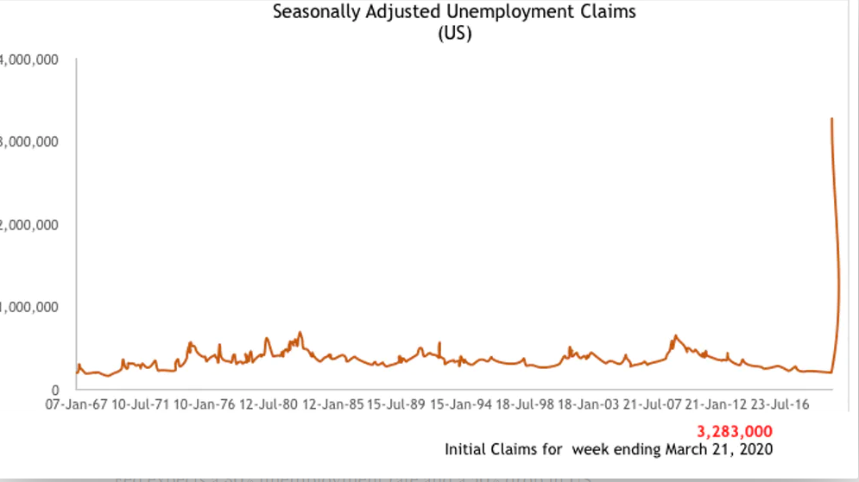
Impact of Global Recession of 2020 on Economy of China
China one of the strongest economies of world was hit sharply by an unknown or novel virus later named as “Novel Crona Virus or Covid-19” after first case was reported in back November 2019 global economies started to feel the impacts of something big was coming. Chinas has become new hub of investments as government of china made changes in its policies to focus on free-market principles(Investopedia n.d.). China has largest world’s population in world due which labor costs in china are lower as compare to other countries which also attracted many firms to start manufacturing units there in china.
Global Recession of 2020 will have deep multiplier effects for china like if recession continued for any longer period of time consumption will reduce, living standards of people will go down, house prices will go down investments will shrink as well.
Global Recession of 2020 has hit china strongly as china was still recovering from the global crisis 2008 which resulted decrease of growth from round about 13% to 7% in one year. Although china has $3trillion foreign reserves China’s government is highly skilled at circling the policy wagons to forestall crisis. Or to at least delay the “Minsky moment,” when a credit-fueled boom goes awry, that befalls all industrializing nations(Pesek n.d.)
Chinese government can have biased numbers regarding the its GDP but you have think like that for big country like china growth of 4% in GDP would be considered as risky territory. Official data reveals that there was significant GDP growth decline in China due to this Global Recession of 2020almost 20% of expected GDP los, Auto Manufacturing business lost 80% sales and exports of china decreased by 17% in the months of January and February (Anon n.d.).
In comparison to United States China’s economy is strong more sustainable with majority of MNC’s workingin china it will help china to come out of this disaster of Global recession of 2020. Recovery can take time but it is expected world’s largest economy will come good this time as well.

References
Ahmed, Kaamil. 2020. “Coronavirus Could Turn Back the Clock 30 Years on Global Poverty.” The Guardian, April 9.
Anon. n.d. “Lockdown Is the World’s Biggest Psychological Experiment - and We Will Pay the Price.” World Economic Forum. Retrieved April 10, 2020a (https://www.weforum.org/agenda/2020/04/this-is-the-psychological-side-of-the-covid-19-pandemic-that-were-ignoring/).
Anon. n.d. “The Effect of COVID-19 on the U.S. Economy - Foreign Policy Research Institute.” Https://Www.Fpri.Org/. Retrieved April 10, 2020b (https://www.fpri.org/article/2020/03/the-effect-of-covid-19-on-the-u-s-economy/).
Anon. n.d. “The Global Economic Effects of Coronavirus.” Retrieved April 11, 2020c (https://www.thenews.com.pk/print/641469-the-global-economic-effects-of-coronavirus).
Dutt, Pushan. n.d. “Economic Effects of Coronavirus Lockdowns Are Staggering – but Health Recovery Must Be Prioritised.” The Conversation. Retrieved April 10, 2020 (http://theconversation.com/economic-effects-of-coronavirus-lockdowns-are-staggering-but-health-recovery-must-be-prioritised-135341).
hermes. 2020. “IMF Sees Global Recession in 2020, Recovery in 2021.” The Straits Times. Retrieved April 11, 2020 (https://www.straitstimes.com/business/economy/imf-sees-global-recession-in-2020-recovery-in-2021).
Investopedia. n.d. “How Many Multinational Corporations Operate in China?” Investopedia. Retrieved April 11, 2020 (https://www.investopedia.com/ask/answers/021015/how-many-multinational-corporations-operate-china.asp).
Pesek, William. n.d. “China’s Recession Will Hurt As Coronavirus Crisis Spreads To U.S. And Europe.” Forbes. Retrieved April 11, 2020 (https://www.forbes.com/sites/williampesek/2020/03/18/chinas-recession-will-hurt-as-coronavirus-crisis-spreads-to-us-and-europe/).

